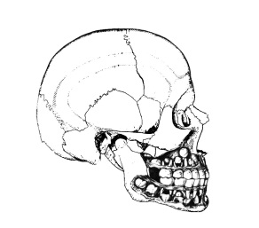
01-09-2013

-avnjde----------------------------------------------------------------------------------------------Bestyrelse
Members of Board
• • •
Formand / President
Troels B. Folkmar
Troels.B.Folkmar@adslhome.dk

Næstformand / Vicepresident
Jens Thorn

Sekretær / Secretary General
Thomas Kofod

Kaserer/ Treasurer
Esben Aagaard

Referent / Assistant Secretary
Janek Dalsgaard Jensen

Foreningen af Specialtandlæger i Tand-, Mund- og Kæbekirurgi
Association for Specialist Dentists in Tooth-, Mouth- og Jaw Surgery in Denmark
Danish Association of Oral & Maxillofacial Surgeons

Dear Industry Partner

Re.The Annual Meeting of FSTMK, Hindsgavl on Oct. 25th – Oct. 26th

Again, this year we have put together an exciting program for our annual meeting in FSTMK.
Our keynote speaker this year is Dr. Bryan Bell, who will talk about virtual surgical planning (VSP).
We hope that as in previous years, the tray turns up about this event.
The Costs for a booth at the Congress is DKK 10,000, - (including lunch and afternoon tea for 2 people). We have negotiated a good price for accommodation, if you should want to attend the dinner and party afterwards.

Homebanking: Reg. no.9219 account no. 4575802929

Sincerely,

Esben Aagaard
Chief Surgeon
Treasurer at FSTMK

